[ZANG] - [Chuanjie] - LNXOS Assignment

Student ID: 699382953

[chuanjiezang@gmail.com](mailto:chuanjiezang@gmail.com)

Although I already have ubuntu linux installed via wsl2 on my computer, for this assignment I initially wanted to reinstall ubuntu by using a removable drive to do the splitting of disks and such in one go, but I accidentally overwrote my win10 system after trying that, and after I reinstalled win10 I decided to go ahead and finish the assignment by using wsl2.

But under wsl2, i cannt use lsbkl, fdisk(i dont know why).

**Under wsl2 ubuntu linux:**

**Step 1. Install Linux**

For this project, we recommend using a fresh installation of Linux.

When asked how to partition the hard disk, choose the option “create custom layout” and use the

values below:

• Create a 100 MB partition for /boot.

• Create a 10 GB partition for /.

• Create a 1024 MB swap partition.

• Leave a non‐allocated space on the hard drive for future use.

When asked to select the software to install, click “Customize now” and select the following

packages:

• Server Configuration Tools

• Windows File Server

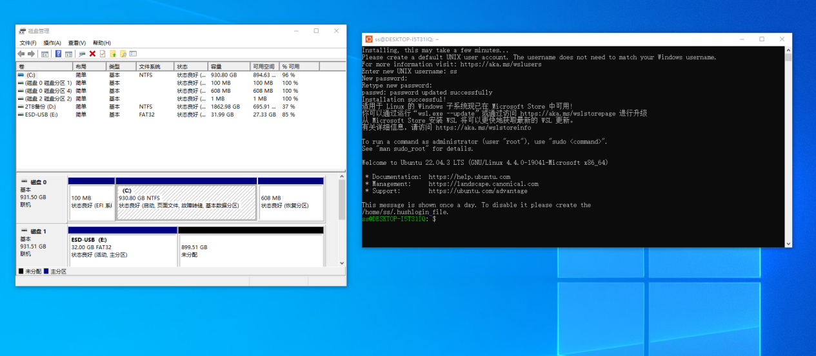

Create a 100 MB partition for /boot.

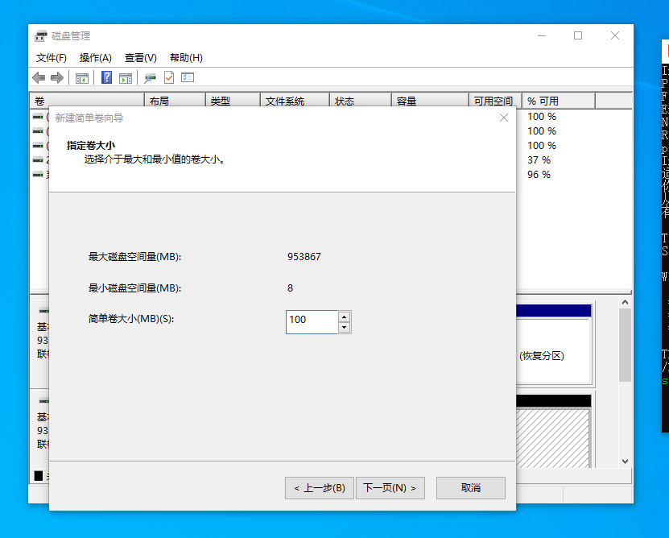

I format them to NTFS.

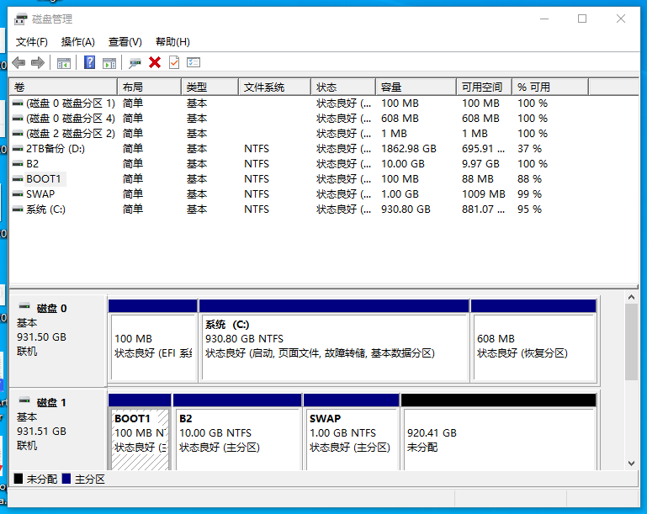

**Step 2. Create a hierarchical directory structure**

• Log into the system as root and create a directory called “project” under the root directory

of the system.

• Create a directory called “data” under the root directory of the system

• Under the project directory, create two more directories and call them “users” and

“documentation”.

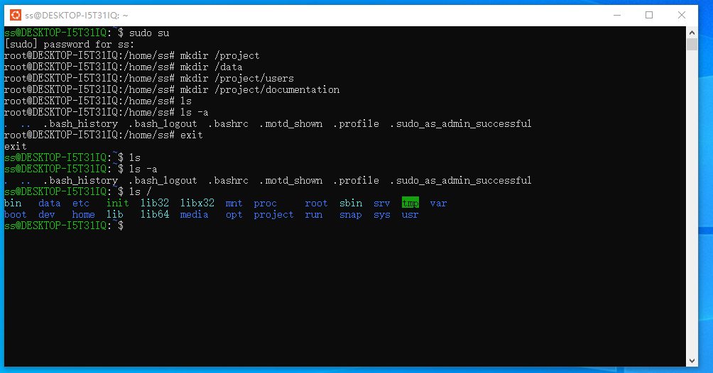

**Step 3. Create and configure users and groups**

All three users will have similar settings. Future users will need the same settings as well.

• User’s passwords must be change every 30 days at the very least, but no more than once a

week.

• All passwords must be at least eight characters long.

• User’s home directories should be automatically created under the directory below the

project directory.

Create the three user accounts using the information below.

• Paul is a manager. His primary group is called “managers”. He is also a member of a group

called “public”.

• Henry is an engineer and his primary group is called “engineers”. He is also a member of a

group called “public”.

• Suzan is a marketing director. Her primary group is called “marketing”. She is also a

member of a group called “public”.

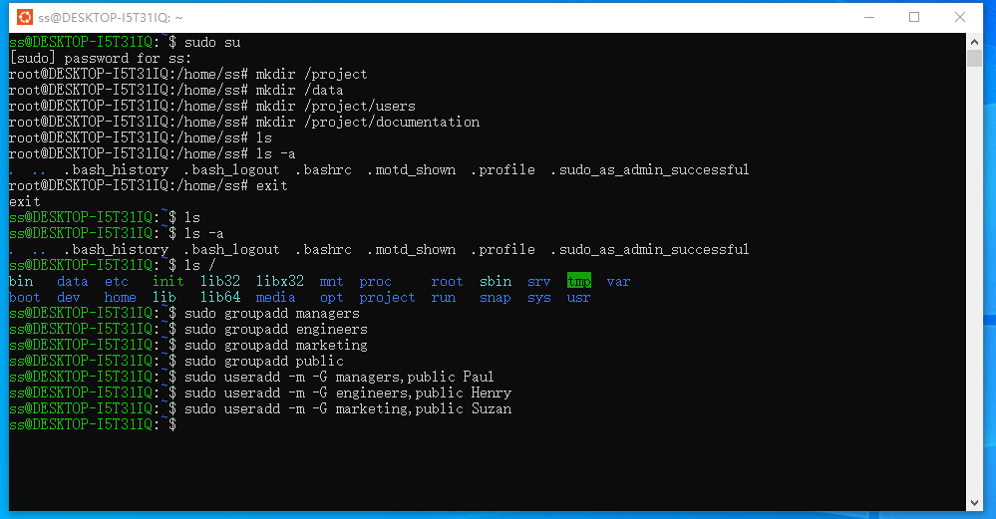

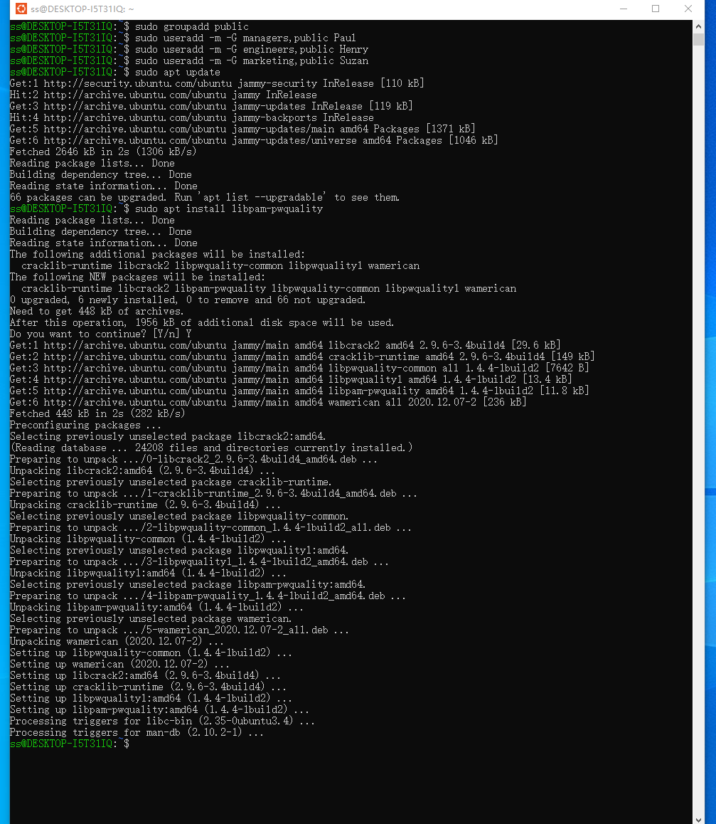

**Use:  
sudo nano /etc/security/pwquality.conf**

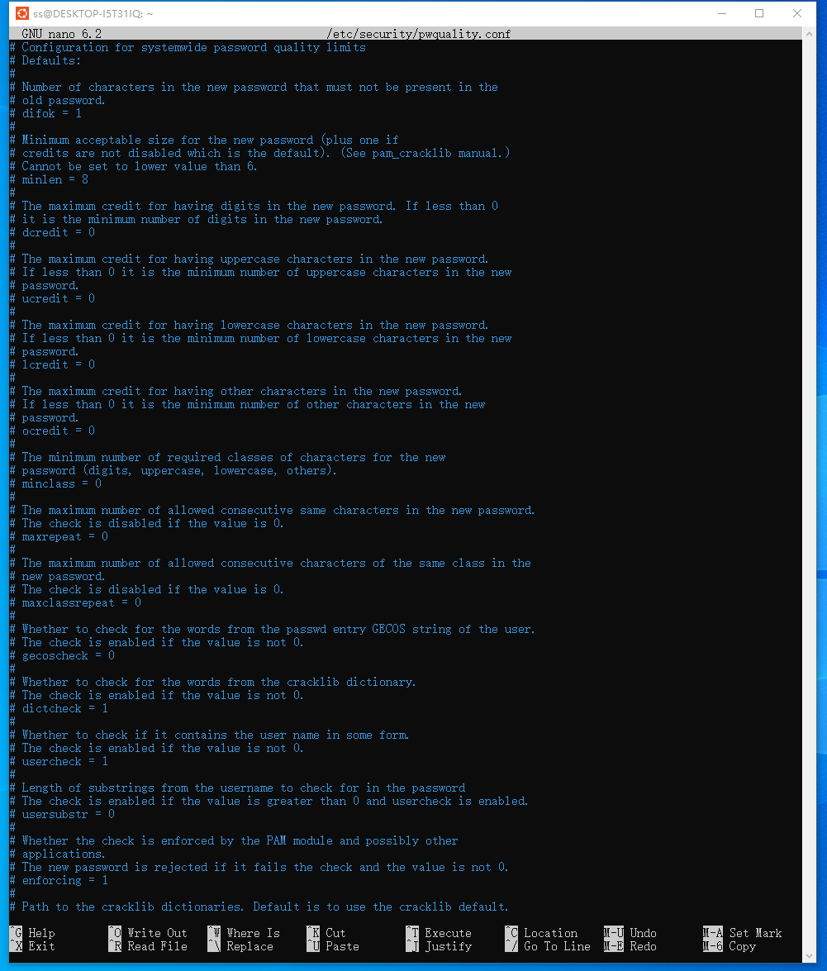

**Makesure ‘ minlen = 8’**

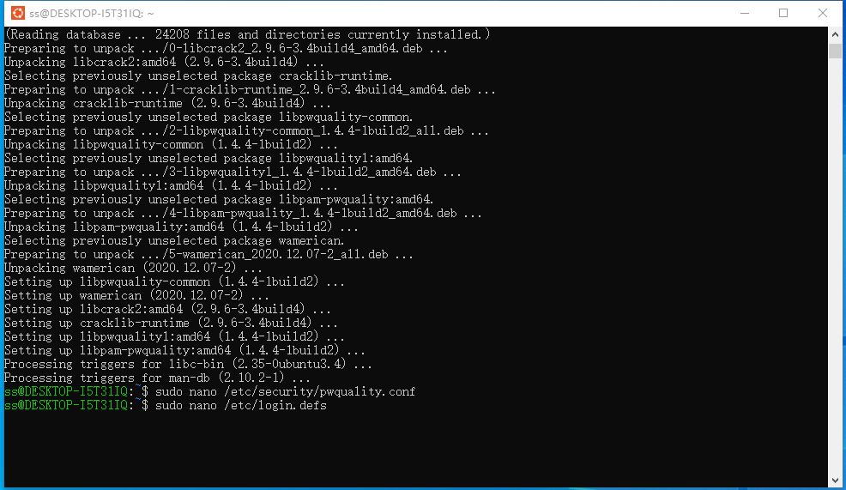

**Makesure ‘pass_min_days’ 7**

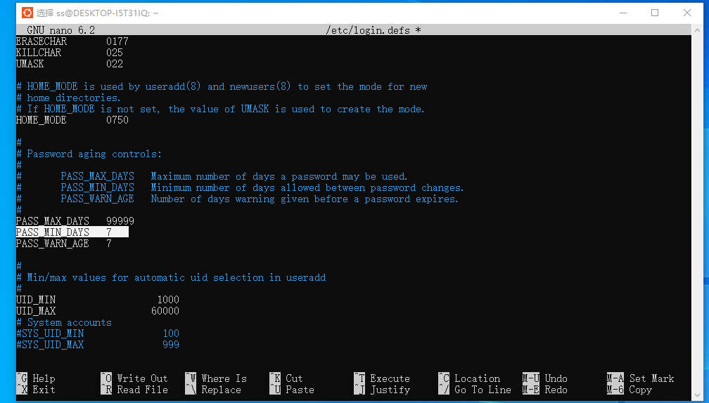

**Set password for Paul, Henry, Suzan**

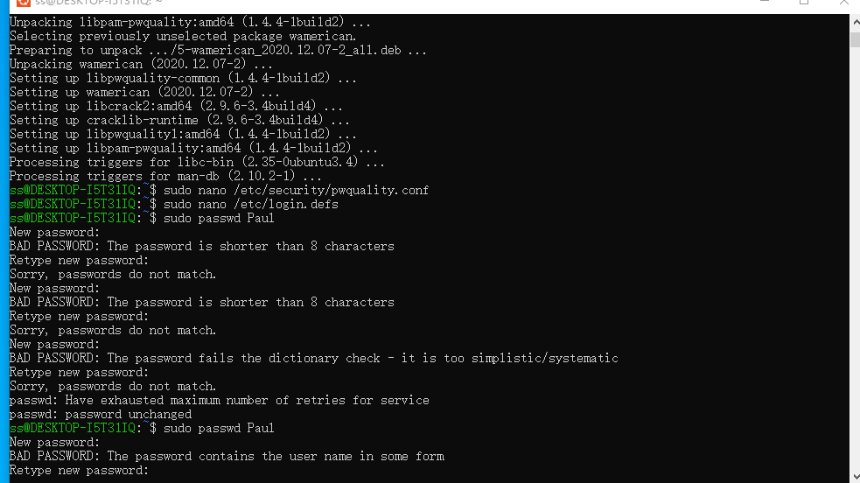

**Step 4. Create, format and mount a partition**

• Using the non‐allocated space, create a 1 GB partition.

• Format the partition using the ext3 file system.

• Mount the partition in the /data directory. Make sure the partition is automatically

mounted each time Linux boots. (Hint: edit /etc/fstab).

• Reboot Linux to check that the partition is automatically mounted in the /data directory.

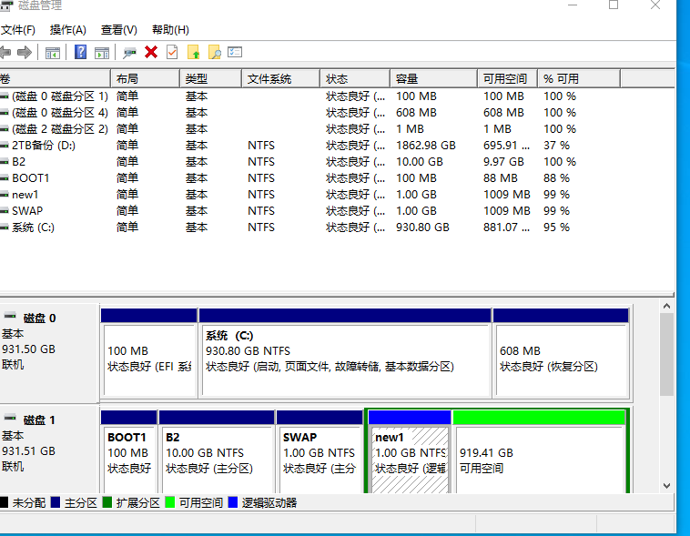

**Right click ‘new1’, set the drive letter to ‘E’, then**

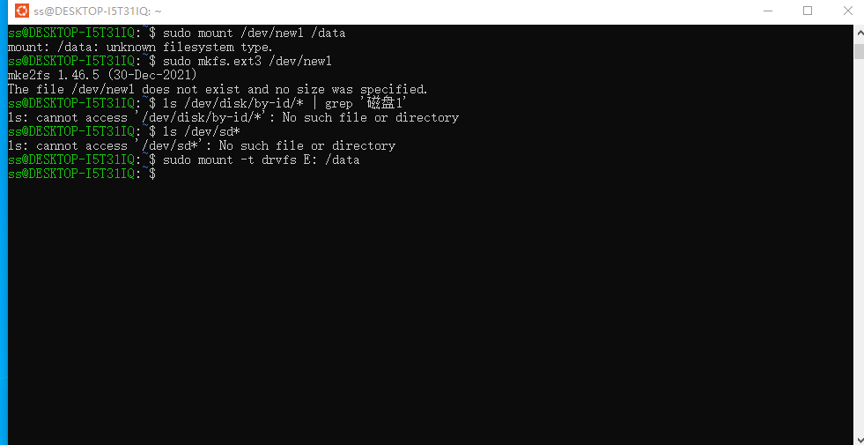

And i can use:  
sudo mkfs.ext3 /dev/sdX

To format it.

**Step 5. Assign permission and quota Limit to the /data directory**

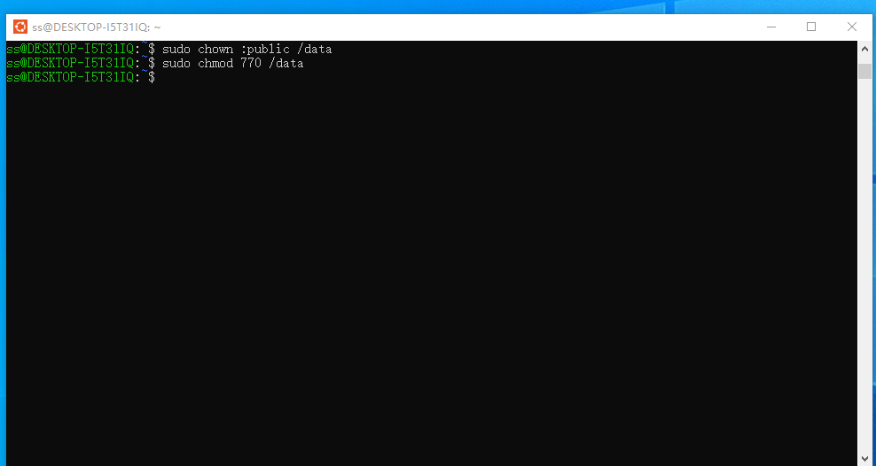

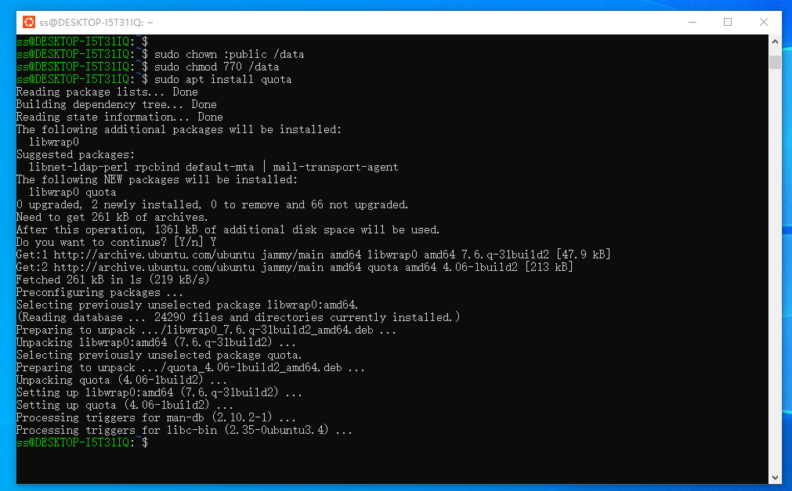

**Use:**

**sudo nano /etc/fstab**

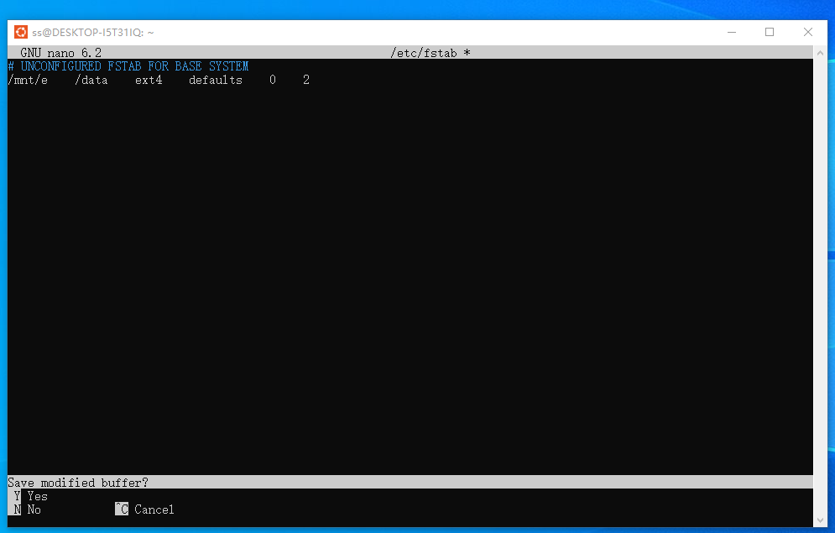

**Then use:  
sudo quotacheck -cug /data  
sudo edquota -u paul  
sudo quotaon /data  
  
to set the disk quota information for users, which include hard/safe limits etc.**

**Step 6. System backup procedure**

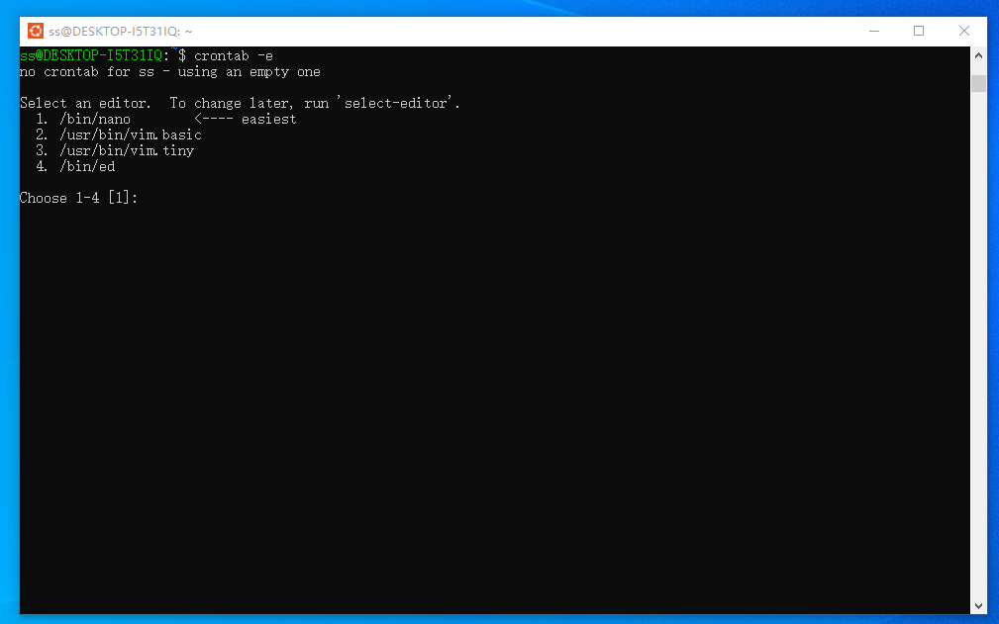

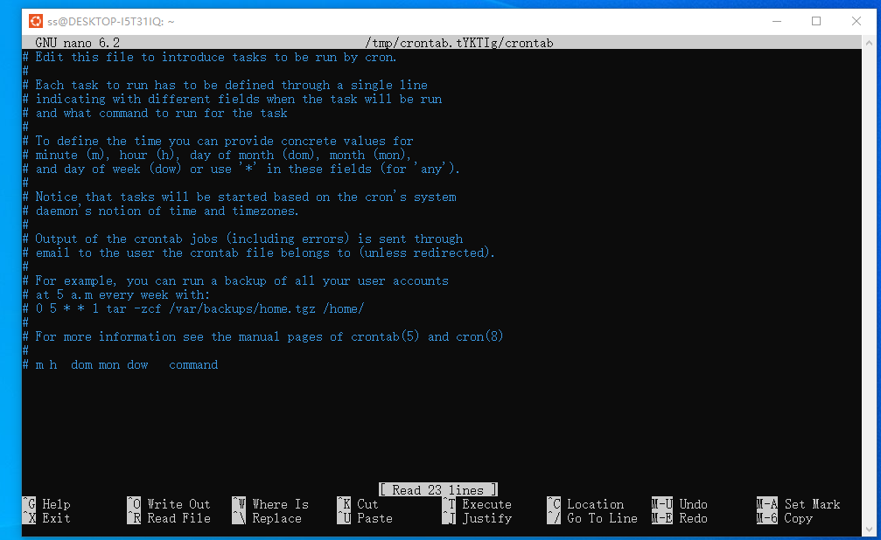

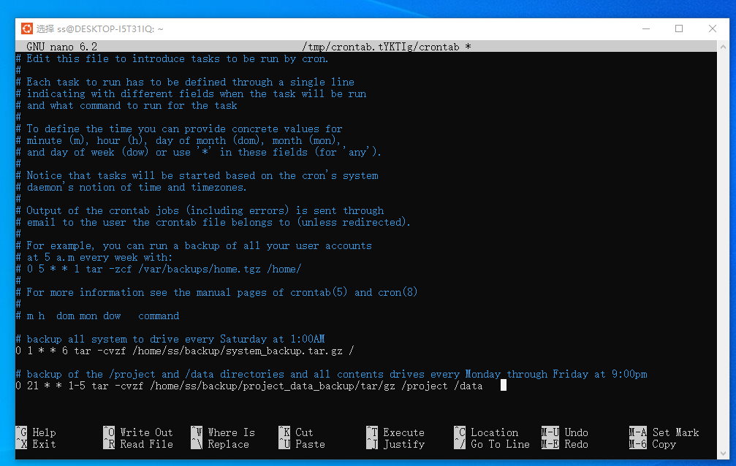

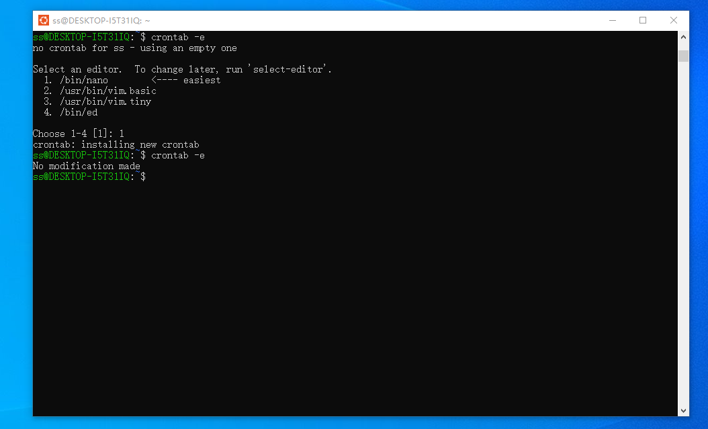

**And make sure that the user running the crontab -e command has sufficient privileges to access the directories and files to be backed up.**

**Step 7. Preparing the project files and printing the files**

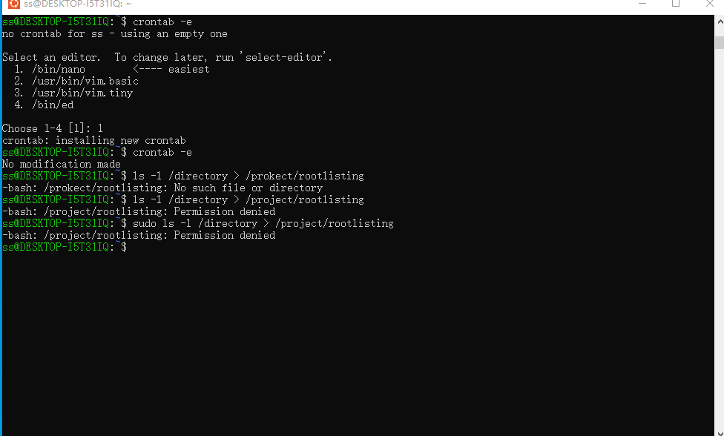

**I guess it’s because of it’s under WSL2.**

**For next i should use:**

**ls -l /project > /project/projectlisting  
ls -l /data > /project/datalisting**

**cp /etc/fstab /project**

**cp /etc/default/useradd /project**

**cp /etc/login.defs /project**

**cp /etc/passwd /project**

**cp /etc/group /project**

**cp -r /var/spool/cron/* /project**

**repquota /data > /project/reportquota**

**Then print those.**